1. 
2. 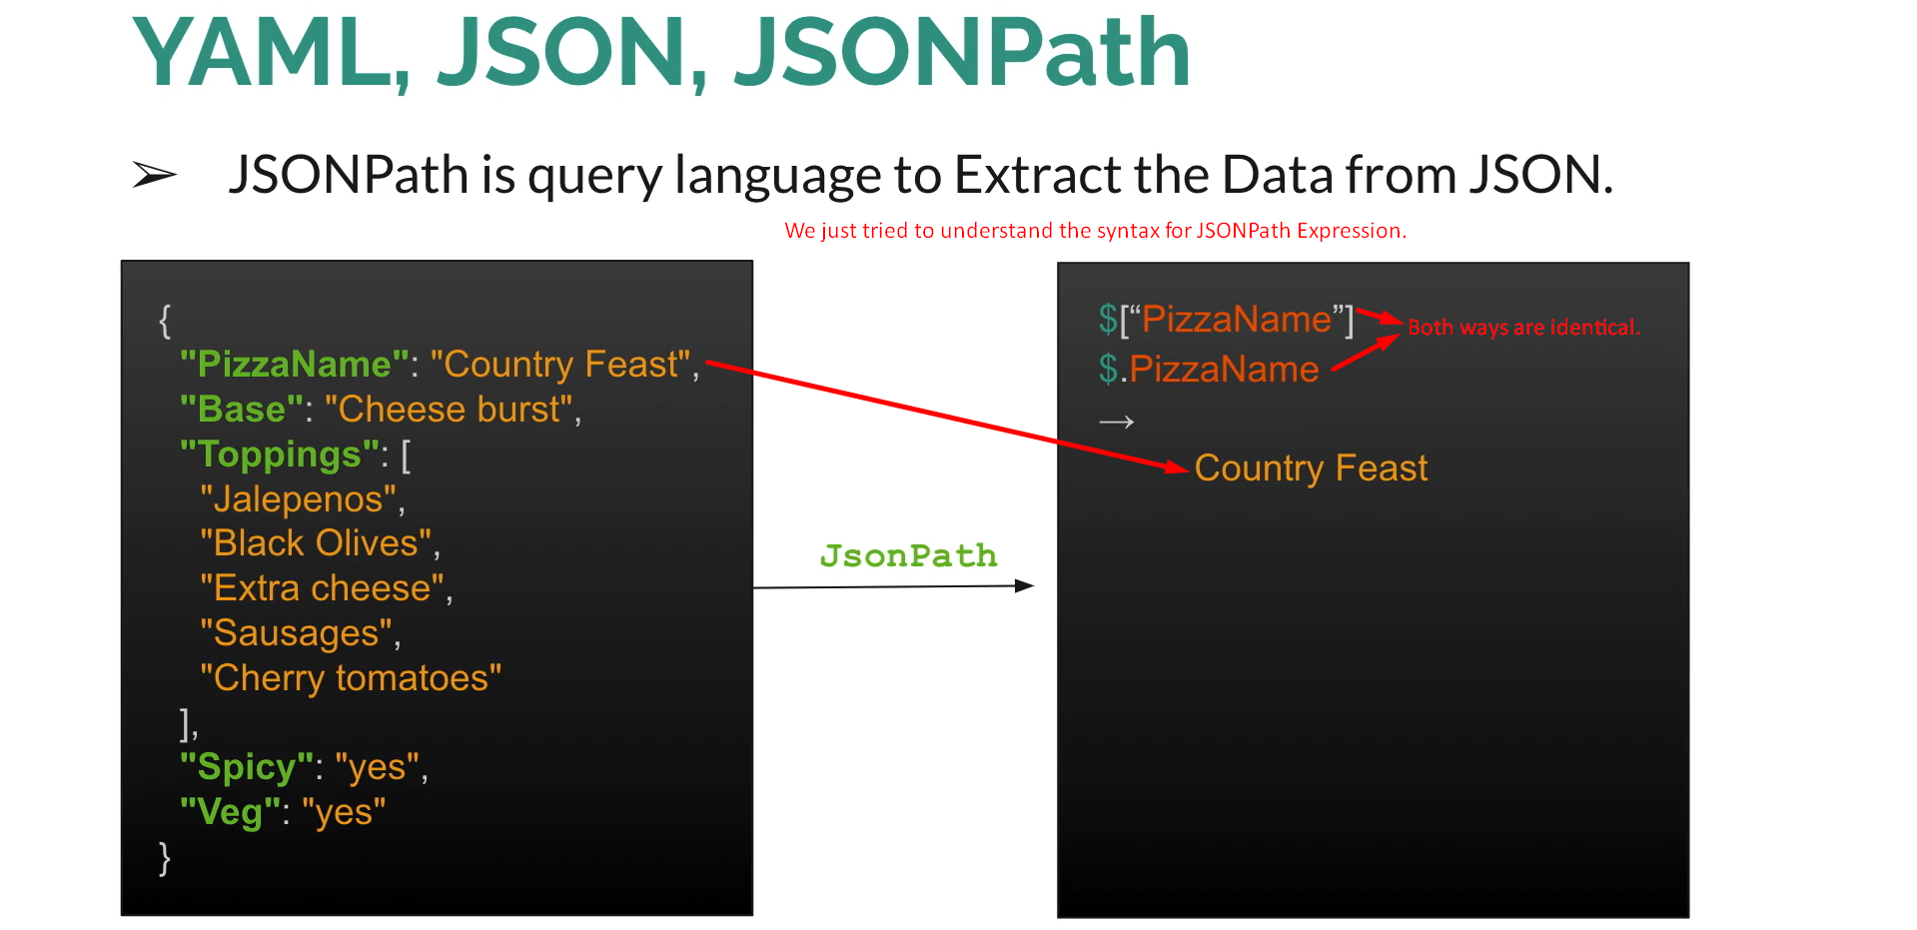
3. 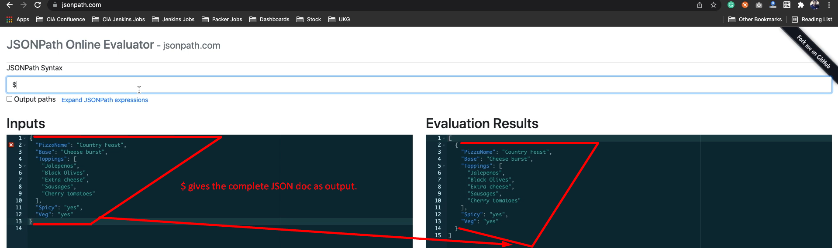
4. Graphical user interface, application

   Description automatically generated
5. JSONPath Expression is case-sensitive.
6. Graphical user interface, text, application, email

   Description automatically generated